Enhancing Personalized Learning of students through Study Material Recommendation in an Adaptive Learning Environment.

Madushan Pathirana – 2020BA024

Supervisor – Dr. L.N.C De Silva

Table of Content

1 Introduction 3

1.1 Introduction E-learning 3

1.1.1 Introduction to adaptive learning 3

1.1.2 Challenges of adopting to adaptive learning methods 5

2 Literature review 5

2.1 Adoptive learning 5

2.2 Knowledge tracing 6

2.3 Item Response Theory (IRT) 7

2.4 Deep knowledge tracing and Graph neural network 7

2.5 Bayesian knowledge tracing 9

2.6 Leaners characteristics 10

2.7 Recommendation system 11

2.7.1 Study material recommendation 11

3 Research problem 12

3.1 Introduction to studying adaptive learning environment. 12

3.2 Research question 12

3.3 Research objectives 12

3.4 Research gap 13

4 Research Methodology 13

5 Data 14

6 Timeline 15

7 Reference 16

Table of figures

[Figure 1‑1 Adaptive e-learning systems' components (Ennouamani and Mahani, 2018) 3](https://wiley-my.sharepoint.com/personal/mpathirana_wiley_com/Documents/research/proposal%20-%20reviewed.docx#_Toc131788235)

Figure 2‑1 structure based knowledge tracing (Tong et al., 2020) 7

# Introduction

## Introduction to E-learning

Education is one of the fundamental pillars in a society that drives intellectual growth and uplifts social standards. According to United Nations, Universal Declaration of Human Rights, Article 26, ‘Everyone has a right to education’ (UN General Assembly, 1948) . beginning of the last century education structured focusing on knowledge and skills without considering the learners expectations and leaners abilities. Hence ‘one size fits all’ education system faced challenges to cater individual student requirements. With the development of the technology personalized teaching and learning frameworks immerged to fill this gap. Some of the developed systems to fill personalized learning gap are Learning Management Systems (LMS), Adaptive Hypermedia Systems (AHS), and Intelligent Tutoring Systems (ITS). Furthermore, in recent years have appeared the Learning Style Based Adaptive Educational Systems (LSAES) (Katsaris and Vidakis, 2021)

## Introduction to adaptive learning

Adaptive learning is a type of scaffolding technique used in educational technology that is tailored to support all stakeholders in an educational institution, including teachers, students, and school administrators. According to (Jan­Martin Lowendahl et al., 2016) “Adaptive learning dynamically adjusts the way instructional content is presented to students based on their responses or preferences. Adaptive learning is increasingly dependent on a large­scale collection of learning data and algorithmically derived pedagogical responses

### Importance of adaptive learning

Adaptive learning saves teachers time and provides data and analytics that help to understand students. For students, it provides a personalized learning experience better suited for their capacity and instant feedback. School administrators can improve student performance, such as pass rate and proficiency. (Clark, Kaw and Braga Gomes, 2022) advise using adaptive learning to improve pre-class preparation for both flipped and blended learning.

How adoptive learning works –

Ennouamani & Mahani, (2018) have summarized adaptive learning systems to 3 models. They

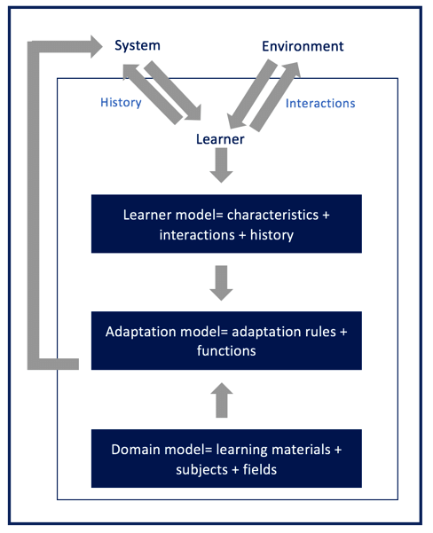

Figure 1‑1 Adaptive e-learning systems' components (Ennouamani and Mahani, 2018)

are Learning model, Adaptation model and Domain model. Learner model contains the student characteristics such as learning style, reasoning style, interests and student performance history. Domain model contains knowledge of the studying domain, study materials and learning objectives. Adaptation model contains the adaptation rules that align the student performance and domain. It asses the student behavior and navigate the student to relevant materials in the domain model. Sophisticated adaptive learning system temporally update it rules and get feedbacks from external and internal learning environments.

Liu et al.,( 2017) Conclude adaptive learning positively impact student performance with empirical evidence, but it depends on the design of the adaptive learning system. It should be user centric and content must properly align with the learning outcomes. System should be able provide meaningful feedback and navigate student only to the relevant content.

### Challenges of adopting to adaptive learning methods

According to (Martin et al., 2020) when educational institutes adopting adaptive learning methods they face 3 types of challenges. They are technology, instruction, and management. There are technological barriers when schools have to connect existing learning management system to adaptive learning methods, real time data sharing challenges and complexity of adaptive systems. Teachers and instructors not having enough experience can lead to adaptation of adaptive learning methods. Educational institutions have to train and monitor how well they adopt the adaptive learning methods. Some time educators resist to adopt adaptive learning methods due differences in the curriculums , additional work load or not having confidence that adaptive learning methods can improve students’ knowledge state. Lack of management support can also lead to adaptive learning method adoption failure. Incompatible organization goals or lack of leadership and insufficient human resources and financial resources can also cause to halt the implementation of adaptive learning systems.

# Literature review

## Adoptive learning

According to Ennouamani and Mahani, (2018) there are multiple 3 main adaptive learning approaches. They are ;

* Macro-Adaptive Approach - This approach allows the user to move between courses at an adapted rate. It also considers the learning objectives and cognitive and intellectual characteristics. The instructor has to initiate the narrative.
* Aptitude-Treatment Interaction (ATI) Approach - This approach identifies the learner's aptitude and then alters the course of action to improve the learner's abilities. These systems can be used to develop Intelligent Tutoring Systems by generating learning materials suited to individual learner's capabilities.
* Micro-Adaptive Approach - This approach analyzes the learner and understands the learner's requirement or knowledge gap. It is a more dynamic system that considers real-time characteristics of the learners.

## Knowledge tracing

Human teachers can measure students' level of understanding and take necessary actions to fill the gaps. In the computer base teaching era, machines must learn the students' degree of understanding and take action to fill the knowledge gap. Abdelrahman, Wang, and Nunes (2023) Recognize this process as **Knowledge Tracing (KT)** . These KTs are widely used in Massive Open Online Courses (MOOCs), Intelligent Tutoring Systems (ITS), educational games, and adaptive learning platforms. However, capturing student knowledge level is not easy because questions can require multiple skills, dependency among skills, and forgetting or decaying knowledge over time. Since John R. Anderson introduced knowledge tracing in 1986, researchers have attempted to develop many machine-learning models to solve KT. Early models are based on Bayesian Knowledge Tracing (BKT). With the rise of classical machine learning models, Logistics regression models started to model KT with different learner traits. Item response theory (IRT) is a branch of these attempts. With the rise of deep learning, a new branch called Deep Knowledge Tracing (DKT) emerged that uses Recurrent Neural Networks (RNN). This branch outperformed previous methods of KT.

There are different KT models to overcome these challenges. And they have incorporated different perspectives of KT to solve these challenges, such as knowledge structures, attention mechanisms, graph representation learning, textual features, and forgetting features.

## Item Response Theory (IRT)

Item theory is a major branch in knowledge tracing. It is a psychometrics method, which means it is statistical framework to analyze and understand the properties of individual test items/questions and the performance of test-takers on each item. It is introduced by (F. M. Lord, M. R. Novick and Allan Birnbaum, 1968).

According to IRT every question has a degree of difficulty and student has a level of ability. Below equation is the basic form of ITR. $p_{ij}$ is the probability of student *i* answering correctly to the question *j*. ai is the ability of student *i* and bj is the difficulty of the question *j.*

$$p_{ij}=\frac{e^{a_{i}-b_{j}}}{{1+e}^{a_{i}-b_{j}}}$$

Assumptions in IRT;

* Probability of student correctly answering a question model as an item response function
* Item response function monotonically increase with respect to the ability of the student
* Questions are conditionally independent.

## Deep knowledge tracing and Graph neural network

Piech et al., (2015) Lead the **Deep Knowledge Tracing** **(DKT).** DKT mainly uses deep learning to predict students' ability to answer a question correctly. There are many branches under DKT. They are Text-aware KT models, Attentive KT models, Graph-Based KT models, Forgetting-aware KT models and Memory-Augmented KT models. This research focuses on Graph-based KT models.

According to (Abdelrahman, Wang and Nunes, 2023) there are three main graph-based KT models. They are

* graph-based knowledge tracing
* graph-based interaction knowledge tracing
* structure-based knowledge tracing (SBKT)

This research leans toward structure-based knowledge tracing as we use knowledge graphs representing relationships between knowledge concepts (KC/learning objective (LO) as per our data set).

Tong et al.,(2020) introduced the structure-based knowledge tracing method. They have tried to solve two main challenges in this paper. They are the temporal impact of exercise sequence and the spatial impact of the knowledge structure or knowledge graph. In order to solve these challenges, they have introduced structure-based knowledge tracing(SBKT). SBKT can simultaneously model the temporal and spatial impacts.

Figure 2‑1 structure based knowledge tracing (Tong et al., 2020)

Figure 2‑1 depict sequence of exercises related to one knowledge structure. Under this structurer there are connected concepts. They are either prerequisites or similar concepts. As the student proceed with the question students knowledge statues of each concept change. It is shown in the radar map in the top. Changes in radar map shows the temporal impact of the students’ knowledge statues and knowledge structures shows how responses impact the learning concept and related(influenced) concepts, which is the spatial impact.

## Bayesian knowledge tracing

Bayesian knowledge tracing (BKT) is one of two main branches of traditional knowledge tracing. BKT models depend on **Mastery Learning Concept**. The mastery learning concept assumes that every student can achieve mastery through practice. But it needs to meet two conditions. They are ;

* mastery learning is that knowledge is appropriately described as a hierarchy of skills
* mastery learning is that learning experiences must be structured to ensure that students master the lower-level skills before moving on to more complex ones

BKT was introduced by (Albert T. Corbertt and John R Anderson, 1994) in 1994. This method considers the probability of a student transitioning from an unlearned to learn state. probability of transition is p(T). It omits the students' ability to forget or transition from a learned state to an unlearned state. But it considers the probability that students may guess the answer p(G) or mistakenly select the wrong answer (slip) p(S).

Equation 2‑1 BKT formula

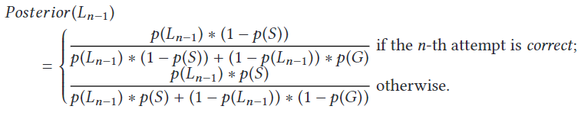

Posterior (Ln − 1) is the posterior probability of being in a learned state given the observation to the n-th attempt by a student.

## Leaners characteristics

Hemmler and Ifenthaler, (2022) have identified internal and external indicators of the learning context for supporting adaptive learning. Based on the authors internal dimensions, Past performance is a one dimension that support toward adaptive learning. It can be measure through previous grades, rank, previous experience with the course content, prior credits and course repetition. All these indicators are included in our data set. Additionally under skills and abilities dimension, prior knowledge indicator also captured in our data set. In contrary there are many other dimensions such as demographics, learning approach, emotions, perception towards teacher/course and etc. Hence our study limited only to student performance and skill/abilities dimension when analyzing learners characteristics in an adaptive learning environment.

Afini Normadhi et al.,( 2019) summarize learners personal traits in 3 main domains and the relevant sub domains.

* Cognition – learning style /cognitive style/ prior knowledge/ personality type/thinking process/working memory capacity.
* Affective – emotions/ mental state/ engagement
* Behavior/psychomotor – cognitive abilities/ performance

Our study based on performance under Behavior/psychomotor and prior knowledge under cognition.

Authors conclude most of the adaptive learning environments build on personal traits under cognitive learning domain. Most frequently used personal trait identification method is computer based detection using machine learning (majority ) , without machine learning or hybrid approach. Authors mentioned most of the research work suffer with small sample size which address in our study. And our work intend to use knowledge graph based approach which was not used mention in (Afini Normadhi et al., 2019) literature review from 2007-2017.

Hsu,( 2012) developed Learning Effort Curve Mode using dynamic real-time based learning effort quantification technique ( related work from the same author). This author has used learning style, learning efficiency and self-efficacy as learner characteristics. In the evaluation author has grouped 125 students in to 16 groups and measured Learning Effort Curve Mode. Author has found, despite the learning style or characteristics, descending learning effort leads to ascending learning performance for high learning efficacy groups . Similarly ascending learning effort leads descending learning performance low learning efficacy groups.

## Recommendation system

Rule-based filtering systems rely on manually or automatically generated decision rules that are used to recommend items to users. Content-based filtering systems recommend items that are considered sufficiently similar to the content descriptions in the user profile. Collaborative filtering systems, also referred to as social filtering, match the rating of a current user for items with those of similar users in order to produce recommendations for items not yet rated or seen (Duval, Klamma and Wolpers, 2007)

### Study material recommendation

Duval, Klamma and Wolpers, (2007) developed an advance recommendation engine to recommend links to students in an E-learning platform. Regular recommendation engines, consider all the users logs at once to recommend links using sequential pattern mining algorithms. These authors have clustered users using k-means clustering algorithm (2-5 clusters) considering number of pages visited and the average knowledge obtained from these pages. Then they have applied AprioriAll, GSP and PrefixSpan sequential pattern mining algorithms for each cluster to generate recommendation rules. This new approach have generated similar or more rules for the same support and with high confidence compared to using all user data at once. As per the conclusions, GSP and PrefixSpan algorithms have shown better slightly better results when there are 2 or 3 clusters. In our approach we can generate 2 or 3 clusters to identify similar students. These authors haven’t consider the learning objectives but students navigation through the web site. Our work can also consider the number of questions and instruction materials referred and the student progress in the learn path ( similar to average knowledge ) as features for the clustering algorithm. Our data set do not contain students activity log but students performance in relation to learning objectives. And the due graph nature of our data set make it more complex to analyze.

Borges and Stiubiener, (2014) developed a recommendation system to suggest learning materials to students based on the learning style of the students and the relevant learning objectives. Authors have clustered the students based on their learning style, they have identified 6 learning styles based on input , perception and process (Richard Felder, 2002), and how different learning materials associated with the learning style. Then utility function developed to measure the distance between learning objectives and learning style(LS) using Manhattan distance. Utility function range from 0 to 6, 0 indicate no difference between LO and LS. 6 indicate LO and LS is totally different from each other. Based on utility function results they and LS they suggest the learning materials. They have tested this system with 28 students and 362 recommendations, 89% of the students are satisfied with the results. In their research , they have not considered the students performance and applied for a small student group. Contrary in our study we consider students performance history and student performance after referring the learning materials. Our study based on large pool of students. Additionally we map LOs with knowledge graphs and how student performance related to each LO.

# Research problem

In this research we study data set from a real world commercial adaptive learning platform. It provides practice questions and assignments targeting science and mathematics school curriculum. Practice questions are called Goals on this platform. Each goal consist with multiple answer questions that related a set of learning objectives. If a student gives correct answer student will proceed to next question. If the student fail the question ,he or she will get a new question or presented with the study materials refresh their knowledge. This platform measure the mastery of a student’s using modified version of IRT and they have to reach 100 mastery to complete a goal.

Subjected adaptive learning platform has not asses the impact of study materials on students learning rate and factors affecting the students learning behavior in an adaptive learning platform.

## Research question

1. What are the factors impact students personalized learning in an adaptive learning environment?
2. What is the impact of learning materials on students personalized learning in an adaptive learning environment ?

## Research objectives

1. Identify the factors that influence personalized learning in an adaptive learning environment
2. Evaluate the effectiveness of study material recommendations in improving student learning outcomes.
3. Explore the use of machine learning algorithms for study material recommendation in an adaptive learning environment.

## Research gap

When referring the literature, knowledge tracing is widely researched under many branches. In the early stages Bayesian knowledge tracing was the most popular method to KT method. Later IRT introduced and recently with the boom of deep learning deep knowledge tracing introduced. DKT out performed all previous methods and under all the branches there are many applications. They are predicting students ability answer a question correctly, recommend learning materials /questions , asses the quality of the education and many more. When our data set compared to the literature, our data set also have sequence of questions under different learning objectives and the correctness of the answers like in other studies. One specialty is in out data set is, middle of the question sequence students have referred to learning materials if they have poorly performed for the related learning objective , and attempted again. This can be used to measure the quality of the learning materials and how it impacts each student. Additionally we attempt to incorporate question difficulty to the problem formulation.

In terms of learner characteristics our study analyze how students prior knowledge and prior performance can be used to cluster students. Additionally we contribute by analyzing impact of study materials/instruction materials shape the leaners characteristics.

# Research Methodology

1. Data collection – Required data is already collected and further explained in chapter 5
2. Data processing – Collected data in tabular format and they are required to change the data types and replace values for the ease of analysis.
3. Data analysis -
   1. Map student performance with direct learning objective, prerequisite learning objectives and study materials.
   2. Develop graph of student performance and learning objectives, then cluster these graphs to identify students with similar behavior
   3. Analyze student clusters and compare clusters identify how each cluster perform and different from other clusters.
      1. How study materials impact
      2. Compare cluster vice learning rate.
      3. Impact of prerequisite learning objectives to proceeding learning objectives
      4. Relationship between learning effort (time spend, number of questions done) with the learning progress
4. Recommendation engine building -
   1. Predict students ability to give a correct answer for a given question under a selected learning objective
   2. Assess the impact referring instructional materials prior answering the question
5. Recommendation engine result evaluation

# Data

This research uses a real-world data set from an International E-learning (courseware) platform that uses state of the art adaptive learning technology. This platform provides educational content targeting schools for Mathematics, Economy, Chemistry, Biology, Physics and Psychology. Based on the research question, identified data was already collected with the organization’s approval.

Subjected Adaptive Learning Platform (ADP) measures the learners' progress level ranging from 0 to 100. Teachers can assign assignments to the student related to a specific Learning Objective(LO). A student has to reach 100 progress to complete the assignment, then the student has achieved the ‘Mastery’ to that LO. Each LO has minimum 4 question, progress of a student for a given LO is

Progress = proficiency score x fraction of the minimum questions learner have tried

If student fail master a LO, student get to do more practice questions. If the student need further support, he or she get more instructions and direct back to the prerequisite LOs.

All the learning objectives, concepts, questions, and course materials are associated to knowledge graphs. These knowledge graphs and progress levels drive the students journey to master a given learning objective. But other characteristics of the student joinery are not considered. Such as time spent on a question, time spent on instructions, quality of the instruction materials, etc.

|  |  |  |
| --- | --- | --- |
| Data | Number of data points | Attributes |
| Student coursework performance | 3.3 million | * Learning objectives * coursework id * user id * progress * question id * correctness of the answer * time spent to answer * time spent for the question instruction * study material id referred |
| Student assignment | 140,000 | * Learning objectives * test id * user id * question id * correctness of the answer |
| Learning objective map (knowledge graph) | 1145 | * Source LO Id (prerequisite LO ID) * Destination LO Id * Source LO Title (prerequisite LO Name) * Destination LO Title |

# Timeline

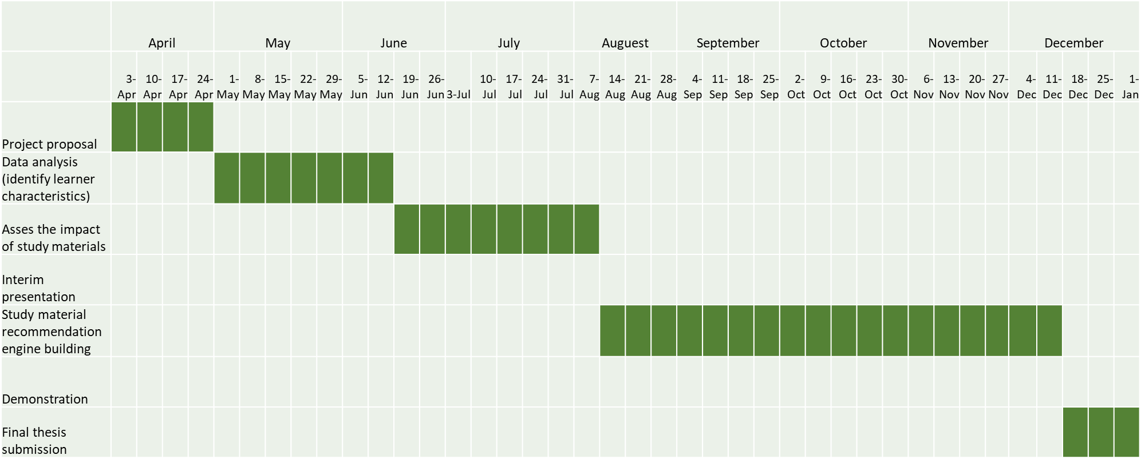

# Reference

Abdelrahman, G., Wang, Q. and Nunes, B., 2023. Knowledge Tracing: A Survey. *ACM Computing Surveys*, 55(11), pp.1–37. https://doi.org/10.1145/3569576.

Afini Normadhi, N.B., Shuib, L., Md Nasir, H.N., Bimba, A., Idris, N. and Balakrishnan, V., 2019. Identification of personal traits in adaptive learning environment: Systematic literature review. *Computers and Education*, 130, pp.168–190. https://doi.org/10.1016/j.compedu.2018.11.005.

Albert T. Corbertt and John R Anderson, 1994. Knowledge Tracing : Modeling the acquisition of procedural knowledge. *User Modeling and User-Adapted Interaction*.

F. M. Lord, M. R. Novick and Allan Birnbaum, 1968. *SOME LATENT TRAIT MODELS*.

Borges, G. and Stiubiener, I., 2014. Recommending Learning Objects Based on Utility and Learning Style. *Opening IEEE-Innovations and Internationalization in Engineering Education* .

Clark, R.M., Kaw, A.K. and Braga Gomes, R., 2022. Adaptive learning: Helpful to the flipped classroom in the online environment of COVID? *Computer Applications in Engineering Education*, 30(2), pp.517–531. https://doi.org/10.1002/cae.22470.

Duval, E., Klamma, R. and Wolpers, M., 2007. *LNCS 4753 - Personalized Links Recommendation Based on Data Mining in Adaptive Educational Hypermedia Systems*. *LNCS*, .

Ennouamani, S. and Mahani, Z., 2018. An overview of adaptive e-learning systems. In: *2017 IEEE 8th International Conference on Intelligent Computing and Information Systems, ICICIS 2017*. Institute of Electrical and Electronics Engineers Inc. pp.342–347. https://doi.org/10.1109/INTELCIS.2017.8260060.

Hemmler, Y.M. and Ifenthaler, D., 2022. Indicators of the Learning Context for Supporting Personalized and Adaptive Learning Environments. In: *Proceedings - 2022 International Conference on Advanced Learning Technologies, ICALT 2022*. Institute of Electrical and Electronics Engineers Inc. pp.61–65. https://doi.org/10.1109/ICALT55010.2022.00026.

Hsu, P.-S., 2012. *LEARNER CHARACTERISTIC BASED LEARNING EFFORT CURVE MODE: THE CORE MECHANISM ON DEVELOPING PERSONALIZED ADAPTIVE E-LEARNING PLATFORM*. *TOJET: The Turkish Online Journal of Educational Technology*, .

Jan­Martin Lowendahl, Terri­Lynn B, Thayer and Glenda Morgan, 2016. *Top 10 Strategic Technologies ImpactingHigher Education in 2016*. [online] Available at: <http://www.gartner.com/analyst/26873>.

Katsaris, I. and Vidakis, N., 2021. Adaptive e-learning systems through learning styles: A review of the literature. *Advances in Mobile Learning Educational Research*, [online] 1(2), pp.124–145. https://doi.org/10.25082/AMLER.2021.02.007.

Liu, M., McKelroy, E., Corliss, S.B. and Carrigan, J., 2017. Investigating the effect of an adaptive learning intervention on students’ learning. *Educational Technology Research and Development*, 65(6), pp.1605–1625. https://doi.org/10.1007/s11423-017-9542-1.

Martin, F., Chen, Y., Moore, R.L. and Westine, C.D., 2020. Systematic review of adaptive learning research designs, context, strategies, and technologies from 2009 to 2018. *Educational Technology Research and Development*, 68(4), pp.1903–1929. https://doi.org/10.1007/s11423-020-09793-2.

Piech, C., Bassen, J., Huang, J., Ganguli, S., Sahami, M., Guibas, L., Sohl-Dickstein, J., University, S. and Academy, K., 2015. *Deep Knowledge Tracing*.

Richard Felder, by M., 2002. *LEARNING AND TEACHING STYLES IN ENGINEERING EDUCATION*. [online] Available at: <http://www.ncsu.edu/felder-public/ILSpage.html>.

Tong, S., Liu, Q., Huang, W., Huang, Z., Chen, E., Liu, C., Ma, H. and Wang, S., 2020. Structure-based knowledge tracing: An influence propagation view. In: *Proceedings - IEEE International Conference on Data Mining, ICDM*. Institute of Electrical and Electronics Engineers Inc. pp.541–550. https://doi.org/10.1109/ICDM50108.2020.00063.

UN General Assembly, 1948. *Universal Declaration of Human Rights Preamble*. Paris.